CoP 5, Session 4 Planning and Exercise Worksheet
For today’s session, select a health behavior that you personally are trying to work on (e.g., lose 10 pounds, work out more consistently, reduce time on social media, etc.). With that health goal in mind, use questions below for each of the 3 ingredients of behavior/habit change to come up with strategies to help you reach the health changes you’re looking for.
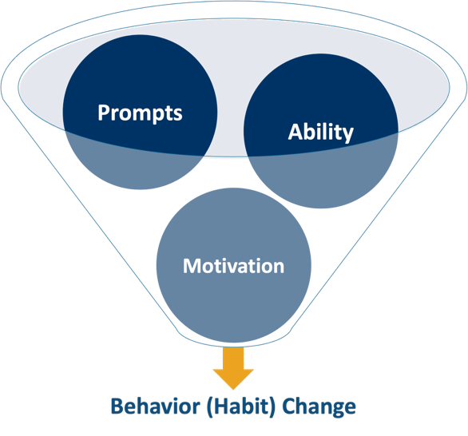
Behavior/Habit Ingredient: Prompts
List three to five ways you can use prompts to change your environment and to make the behaviors you want more visible. (e.g., set my alarm five times a day to drink more water, ask a friend to call every evening to see if I worked out that day, keep a scale in front of the fridge, set out gym clothes the night before, take a different route to/from work, etc.). Remember, make it obvious and create your elephant!

Behavior/Habit Ingredient: Ability
Think of the health change you want to make. List three to five simple, quick behaviors you could do right now, in the next hour, or today, that get you closer to the health habit you want. (e.g., do deep breathing or meditate for 10 minutes, take a walk around the block, do 10 squats and 10 sit-ups, etc.). Remember, make it easy and KISS (keep it simple, silly)!

Behavior/Habit Ingredient: Motivation
List three to five ways you could make the actions you identified in the routine/response phase immediately rewarding or satisfying for you. (e.g., if I walk for 10 or more minutes, I can scroll on Instagram for five minutes; after doing squats/sit-ups, I check it off on my achievement list; listen to my favorite playlist when I eat a healthy meal.). Remember, make it fun…the journey is the reward.

As a bonus, imagine how it feels to complete these behaviors and the sense of satisfaction and achievement. When you do accomplish those behaviors, take time to congratulate and feel the satisfaction or sense of accomplishment. Be sure to make a mental note of the sensations. If you’re inclined, write, journal, or tell a friend about it.

Notes

Action Steps
Two things I will do in the next two weeks to incorporate behavior change strategies to support patients toward healthier habits

